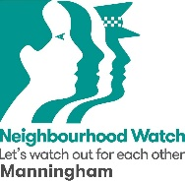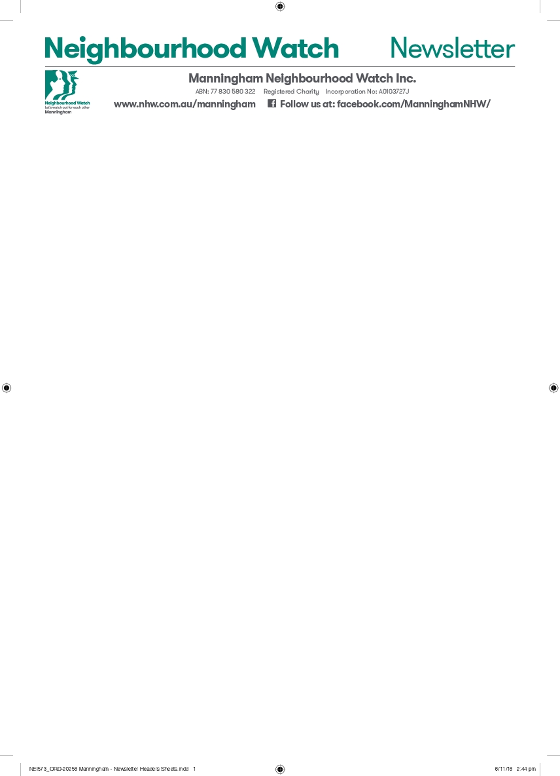

**ANNUAL GENERAL MEETING**

**10:00am on Thursday 9 October 2025**

**PROXY FORM**

**This Proxy form must be in the hands of the Secretary**

**at email: morrisicam@optusnet.com.au**

**no later than 5:00pm on Wednesday 8 October 2025.**

**(Alternatively, drop the Proxy form in the letterbox at 20 Norweena Street Doncaster)**

[🡸 insert name by left clicking then typing ]

I ,

[🡸 insert address by left clicking then typing]

of

being a member of Manningham Neighbourhood Watch Incorporated, hereby appoint

the Chairman of the meeting [X the box by clicking]

[🡸 insert name of person

attending the meeting]

OR

as my proxy to vote on my behalf at the meeting.

My Proxy is authorised to vote as indicated below for the following resolutions and

where I make no election my Proxy can vote as they choose.

Motion: That the Annual Report of Manningham NHW Inc for 2024/25 be approved.

For  Against  Abstain [X relevant box by clicking]

Motion: That the Financial Statements for Manningham NHW Inc for 2024/25 be approved.

For  Against  Abstain [X relevant box by clicking]

(Typed named will be

taken as signature)

Signed